Sponsor-a-Step on the Spiral Staircase

Leave a Legacy at the DeTour Reef Light

Please fill in the form below and send to:
DRLPS, PO Box 307, Drummond Island MI 49726
Name:
__________________________________________________________
Address:
__________________________________________________________
City/State/ZIP:
__________________________________________________________
Phone:
__________________________________________________________
Email:
__________________________________________________________

Please indicate below how you want the name(s) and other data (in memory or honor of) to appear on the Plaque:
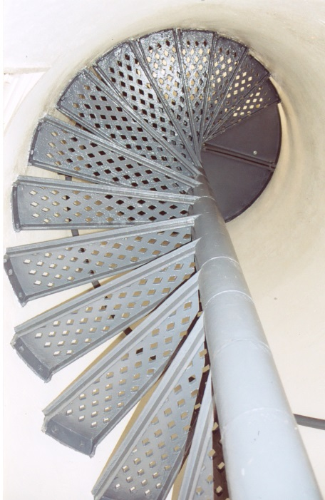
______________________________________________________________

______________________________________________________________

______________________________________________________________

______________________________________________________________
If you wish to Sponsor-a-Step as a gift, acknowledgements are available to send to the recipient.
Cost is $1,500 and tax-deductible as allowed by law.
Please enclose Check or Money Order (payable to DRLPS), or credit card:
Visa MasterCard Discover
Acct #:________________________________________
Expiration Date:_________ Today’s Date____________

Thank you We’ll Keep the Light on for You!
DeTour Reef Light Preservation Society
906-493-6609 www.DRLPS.com EIN 38-3387252

